Jesus Christ, King of the Universe

1st Reading: Ezekiel 34:11-12, 15-17
God promises to personally care for his people, as the shepherd cares for the sheep
Thus says the Lord God: I myself will search for my sheep, and will seek them out. As shepherds seek out their flocks when they are among their scattered sheep, so I will seek out my sheep. I will rescue them from all the places to which they have been scattered on a day of clouds and thick darkness. I will bring them out from the peoples and gather them from the countries, and will bring them into their own land; and I will fed them on the mountains of Israel, by the watercourses, and in all the inhabited parts of the land. I will feed them with good pasture, and the mountain heights of Israel shall be their pasture; there they shall lie down in good grazing land, and they shall feed on rich pasture on the mountains of Israel.
I myself will be the shepherd of my sheep, and I will make them lie down, says the Lord God. I will seek the lost, and I will bring back the strayed, and I will bind up the injured, and I will strengthen the weak, but the fat and the strong I will destroy. I will feed them with justice. As for you, my flock, thus says the Lord God: I shall judge between sheep and sheep, between rams and goats:
Responsorial: Psalm 22:1-3, 5-6
Response: The Lord is my shepherd; there is nothing I shall want.
The Lord is my shepherd;
there is nothing I shall want.
Fresh and green are the pastures
where he gives me repose. Resp:
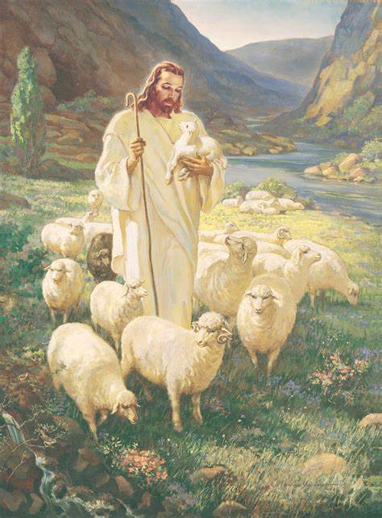
Near restful waters he leads me,
to revive my drooping spirit.
He guides me along the right path;
he is true to his name. Resp:
You have prepared a banquet for me
in the sight of my foes.
My head you have anointed with oil;
my cup is overflowing. Resp:
Surely goodness and kindness shall follow me
all the days of my life.
In the Lord’s own house shall I dwell
for ever and ever. Resp:

2nd Reading: 1 Corinthians 15:20-26, 28
At the end of the world, all enemies will be overcome and Christ will rule as universal king
Christ has been raised from the dead, the first fruits of those who have fallen asleep. For as by a man came death, by a man has come also the resurrection of the dead. For as in Adam all die, so also in Christ shall all be made alive. But each in his own order: Christ the first fruits, then at his coming those who belong to Christ. Then comes the end, when he delivers the kingdom to God the Father after destroying every rule and every authority and power. For he must reign until he has put all his enemies under his feet. The last enemy to be destroyed is death.
When all things are subjected to him, then the Son himself will also be subjected to him who put all things under him, that God may be everything to every one.

Gospel: Matthew 25:31-46
We will be judged by the standard of visible, tangible love
Jesus said to them, “When the Son of Man comes in his glory, and all the angels with him, then he will sit on the throne of his glory. All the nations will be gathered before him, and he will separate people one from another as a shepherd separates the sheep from the goats, and he will put the sheep at his right hand and the goats at the left. Then the king will say to those at his right hand, ‘Come, you that are blessed by my Father, inherit the kingdom prepared for you from the foundation of the world; for I was hungry and you gave me food, I was thirsty and you gave me something to drink, I was a stranger and you welcomed me, I was naked and you gave me clothing, I was sick and you took care of me, I was in prison and you visited me.’
Then the righteous will answer him, ‘Lord, when was it that we saw you hungry and gave you food, or thirsty and gave you something to drink? And when was it that we saw you a stranger and welcomed you, or naked and gave you clothing? And when was it that we saw you sick or in prison and visited you?’ And the king will answer them, ‘Truly I tell you, just as you did it to one of the least of these who are members of my family, you did it to me.’
Then he will say to those at his left hand, ‘You that are accursed, depart from me into the eternal fire prepared for the devil and his angels; for I was hungry and you gave me no food, I was thirsty and you gave me nothing to drink, I was a stranger and you did not welcome me, naked and you did not give me clothing, sick and in prison and you did not visit me.’
Then they also will answer, ‘Lord, when was it that we saw you hungry or thirsty or a stranger or naked or sick or in prison, and did not take care of you?’ Then he will answer them, ‘Truly I tell you, just as you did not do it to one of the least of these, you did not do it to me.’ And these will go away into eternal punishment, but the righteous into eternal life.”

Reflections:
In our life, we might have had the experience of doing something for somebody and only subsequently discovering that it meant far more to that person than you realised at the time you did it? We are not always aware of the good we might be doing. We don’t always appreciate how significant our actions are for others or how much our presence means to them. In some ways that can be a good thing, because it can prevent us from becoming too proud, or taking ourselves too seriously. In other ways it may not be a good thing because we can fail to value something in ourselves that others value much. We may be tempted to give up doing something that people really value because we are unaware of how significant it is. We may think we are doing nothing particularly worthwhile, when we act we may be doing something of real value.
In this Gospel passage, there are two groups of people. The first group were amazed to discover that what they had done in life was far more significant than they had realised. Only at the end of their lives did they realise that their ordinary simple acts of kindness and consideration were in fact serving the Lord of Lords and King of Kings. To their amazement, they discovered that there was a much deeper dimension to what they were doing than they had ever suspected. In attending to the ordinary, they were, in reality engaging with the eternal. “When did we see you?… ” they asked the Son of Man. His reply was, “In so far as you did this to one of the least, you did it to me.” What they did in a matter-of-fact way turned out to have eternal significance. In dealing with their broken and troublesome and unfortunate neighbours, they were, in reality, dealing with the Lord of the Universe. What they had been doing was far more significant than they could ever have dreamt, and ha consequences far beyond what they realised at the time.
It can be difficult for us to realise that in our ordinary dealings with each other we are in a real sense dealing with the Lord, and that is especially true when we are confronted with others in all their brokenness and need. It is in the ordinary, every day affairs of life that we are responding to the Lord. The care that someone gives to a sick relative is care given to the Lord, whether that is realised or not. The welcome we give to a stranger who feels vulnerable in a foreign environment is a welcome given to the Lord.
Another aspect we can reflect on is that of an act of kindness in our communal and social life. A glass of water given out of goodness, seems like a very low threshold for a personal friendship with Christ. Christians have always had a strong trust in Christ’s humanity; he was like us in every way except that he did not sin. Although this Sunday portrays him returning in regal splendour, the judgments of Jesus are not like ours either. He seeks good among the ordinary and the bad alike; too often we seek bad among the ordinary and the good alike. For Jesus, the sinner who does a single act in kindness can be saved. For the rest of us, the saint that does something wrong is tarnished forever.
The Lord Jesus’ hands stretched out in forgiveness to those who had nailed them down. Our hands stretch out to point in criticism at the wrong-doer. But we have a dominant image of what a judge is like and how a judge should act. It is not surprising that the image of Jesus as a fair but stern judge is deeply set with many Christians.
Just as Jesus told the soldiers arresting him that his kingdom was not of this world; his standard of judgment is not of this world either. That should be good news, although not everybody sees it that way.
Also, in the Gospel passage today, the way we relate to prisoners or ex-prisoners reveals how we relate to the Lord.
In the Gospel, Jesus doesn’t say “I was imprisoned for no good reason and you visited me,” or he doesn’t say, “I was imprisoned because of my witness to the gospel and you visited me.” No, it is much simpler than that, “I was in prison,” full stop. No attempt is made to distinguish one prisoner from another or one crime from another. How we treat our prisoners, regardless of what they have done, is a commentary on how we treat the Lord himself. This Gospel reading gives no encouragement to the attitude of lock them up and throw away the key. How we try to integrate ex-prisoners into our community, our society, and use resources to help them build a new life for themselves that is crime-free, is also making a statement about how we are receiving the Lord’s coming to us. Amen.

